**Arduino LED dice - How to guide**

Equipment:

* Arduino
* 7x LEDs
* 8x resistors
* A button
* Breadboard
* Some jumper wires

Step 1

Connect the components (resistors, push button, LEDs) to the breadboard like in the following pictures

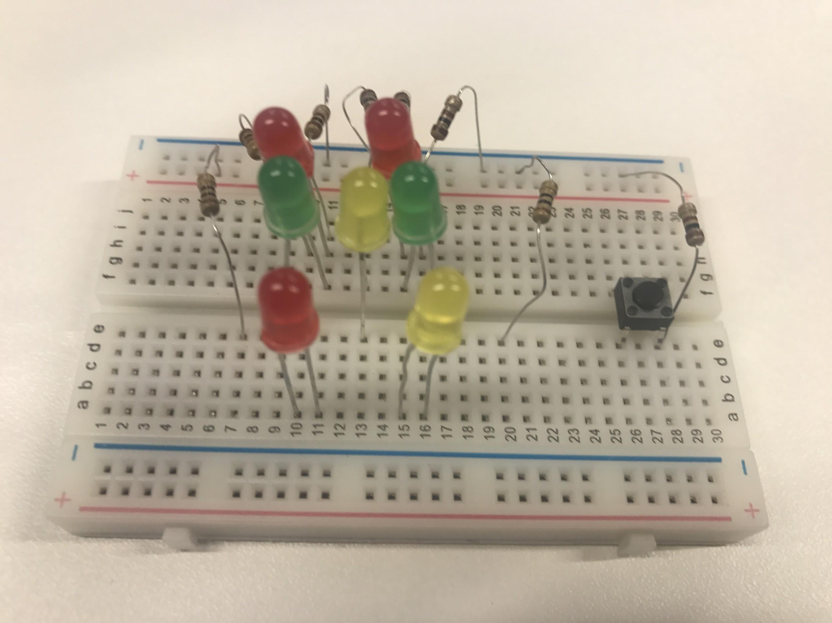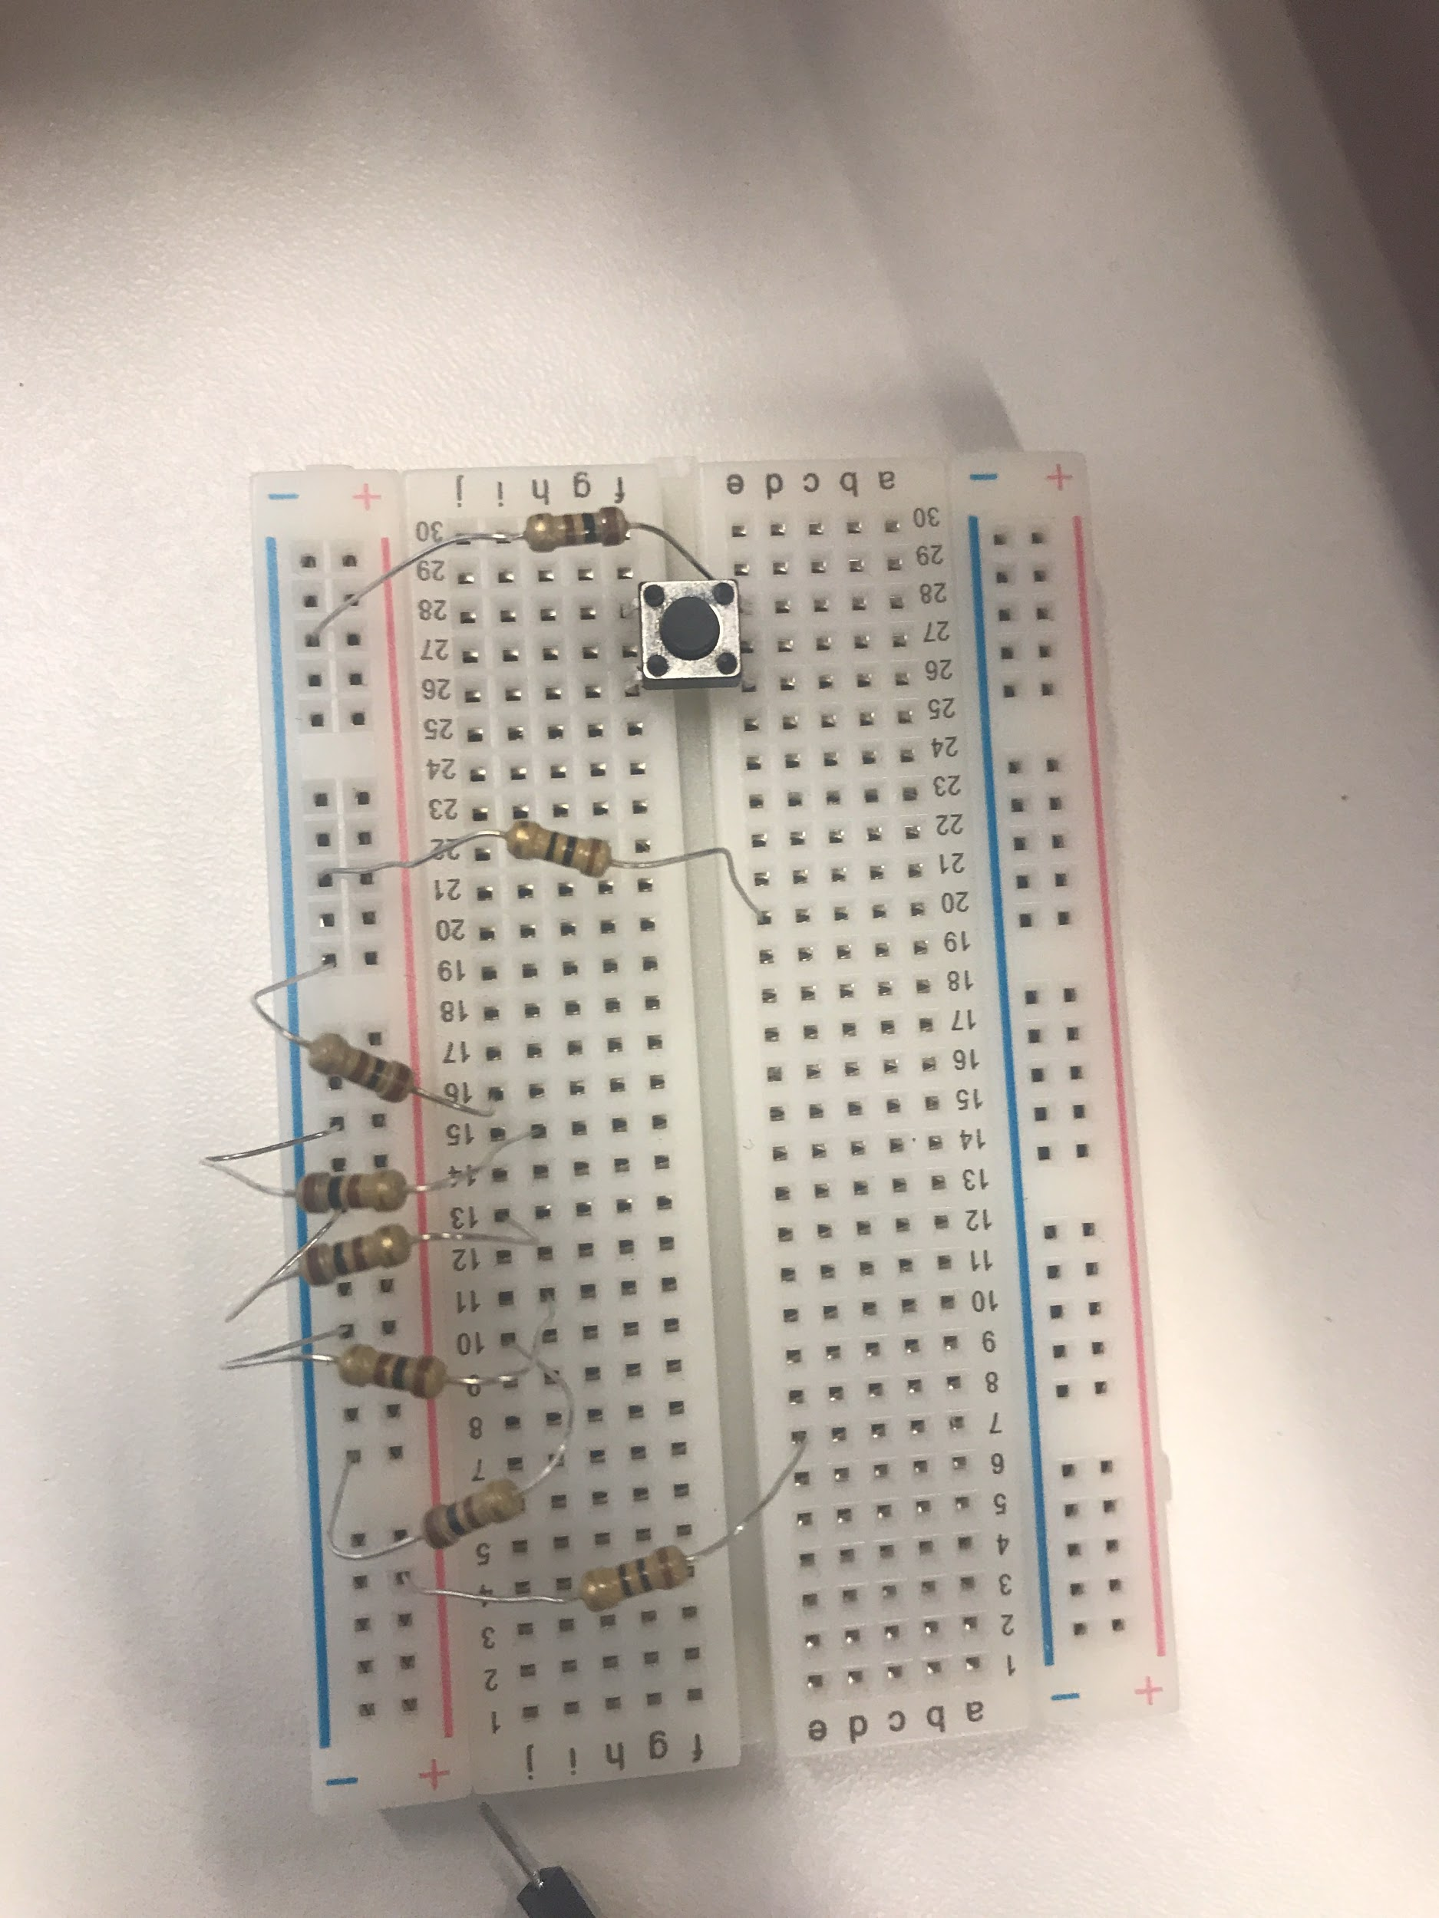

Step 2

Connect the wires to the breadboard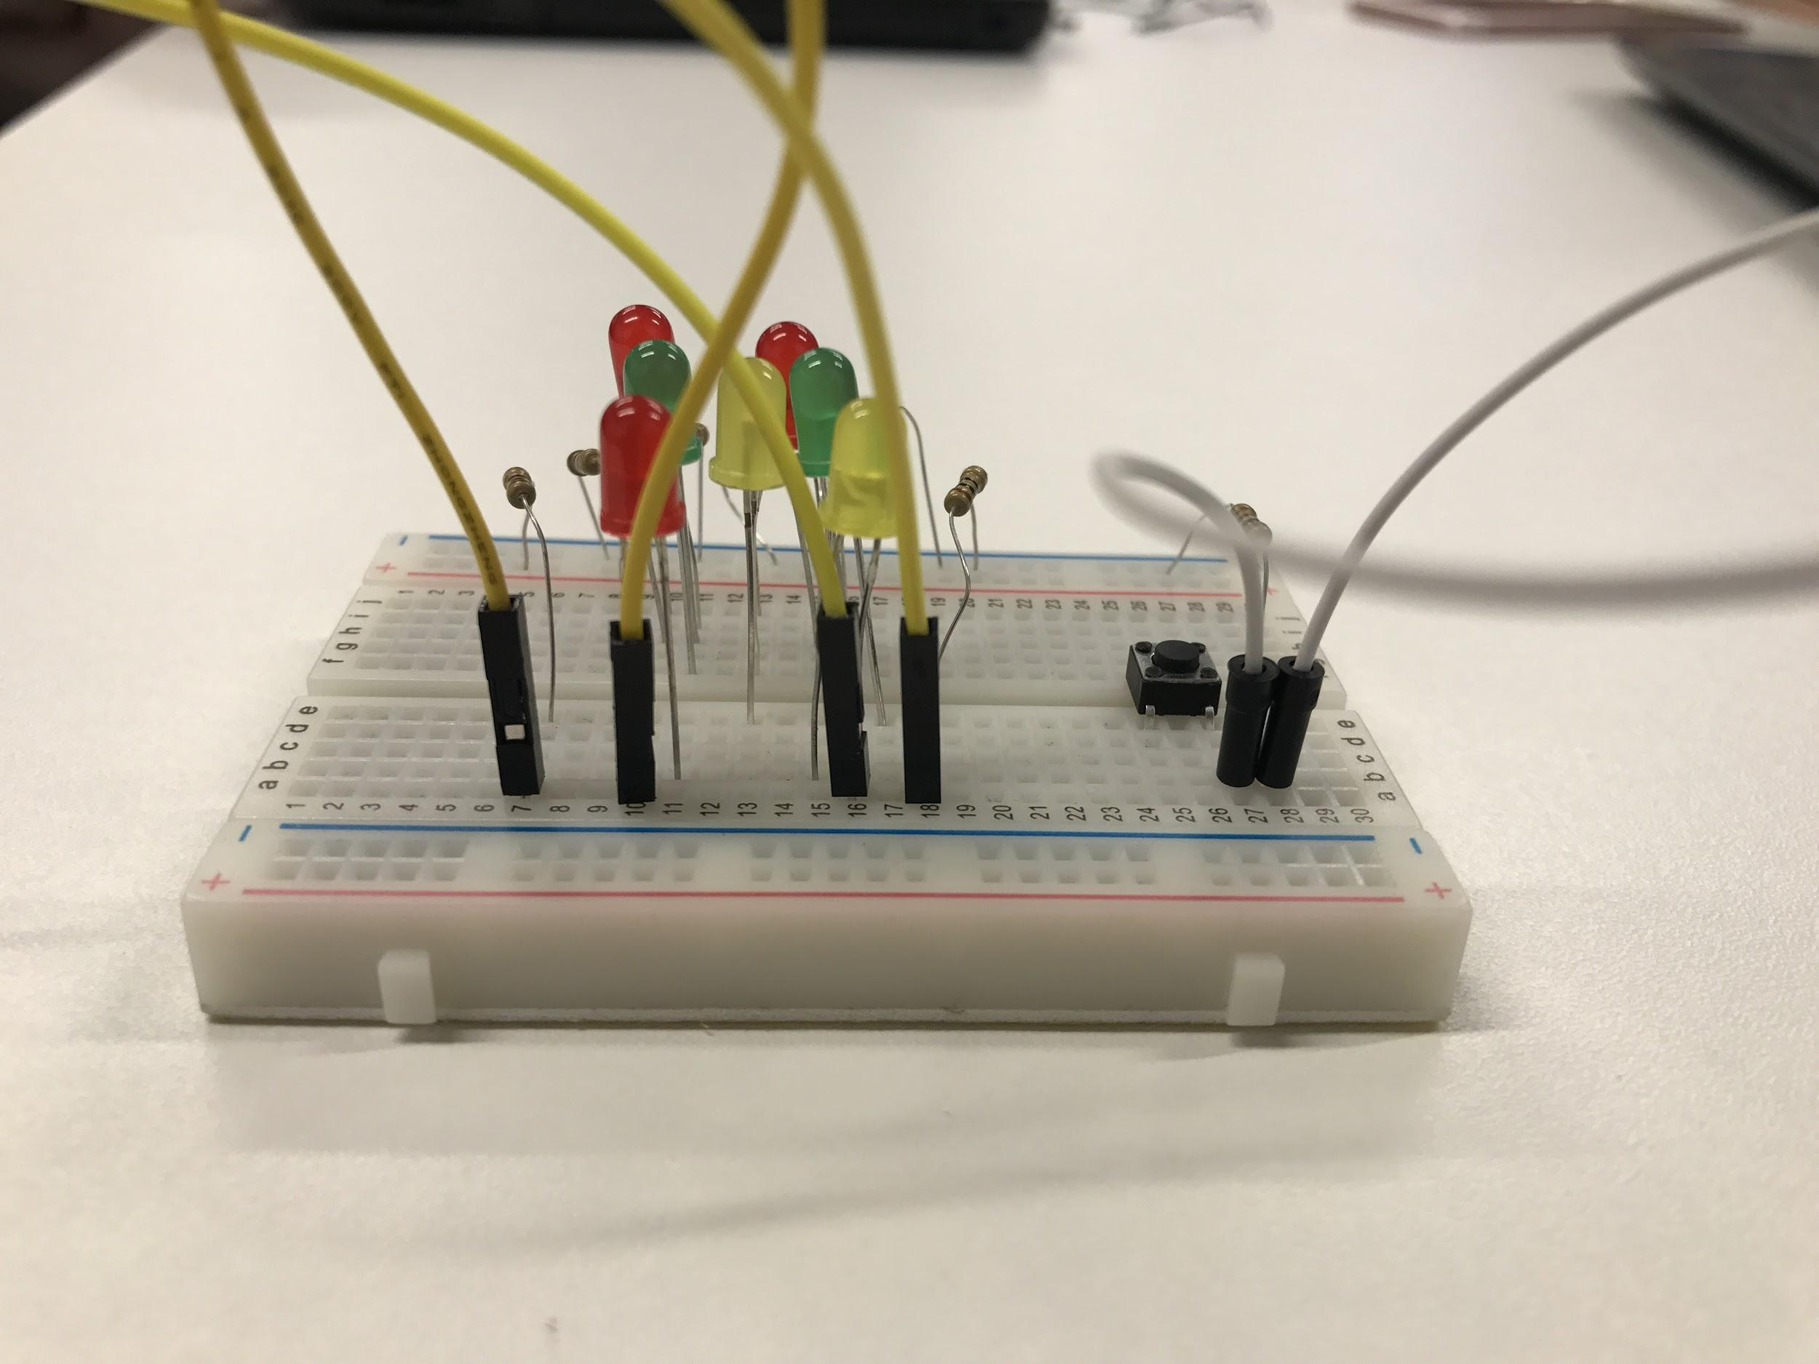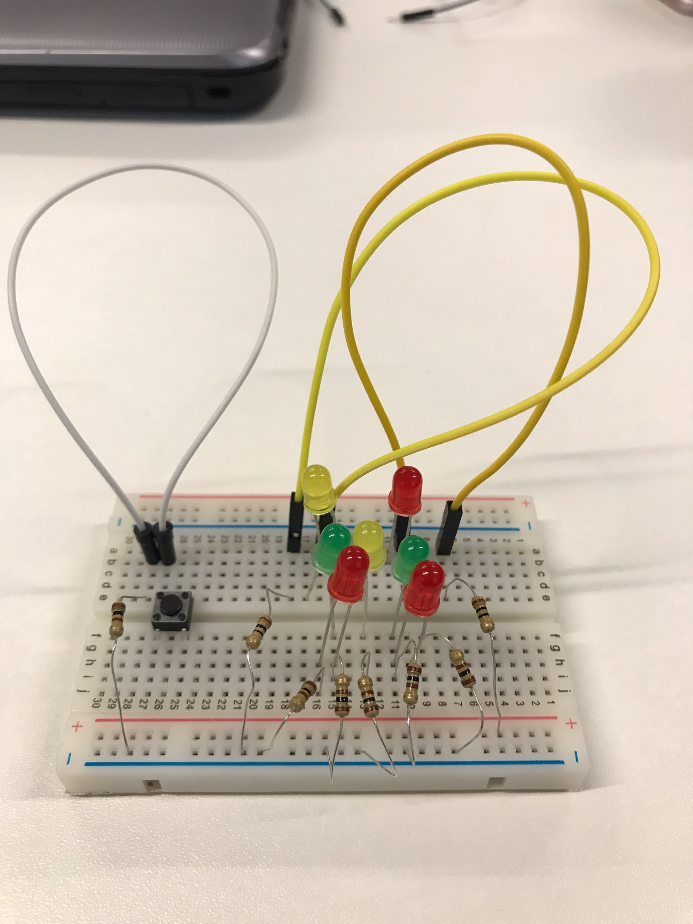

Step 3

Connect the wires to the Arduino

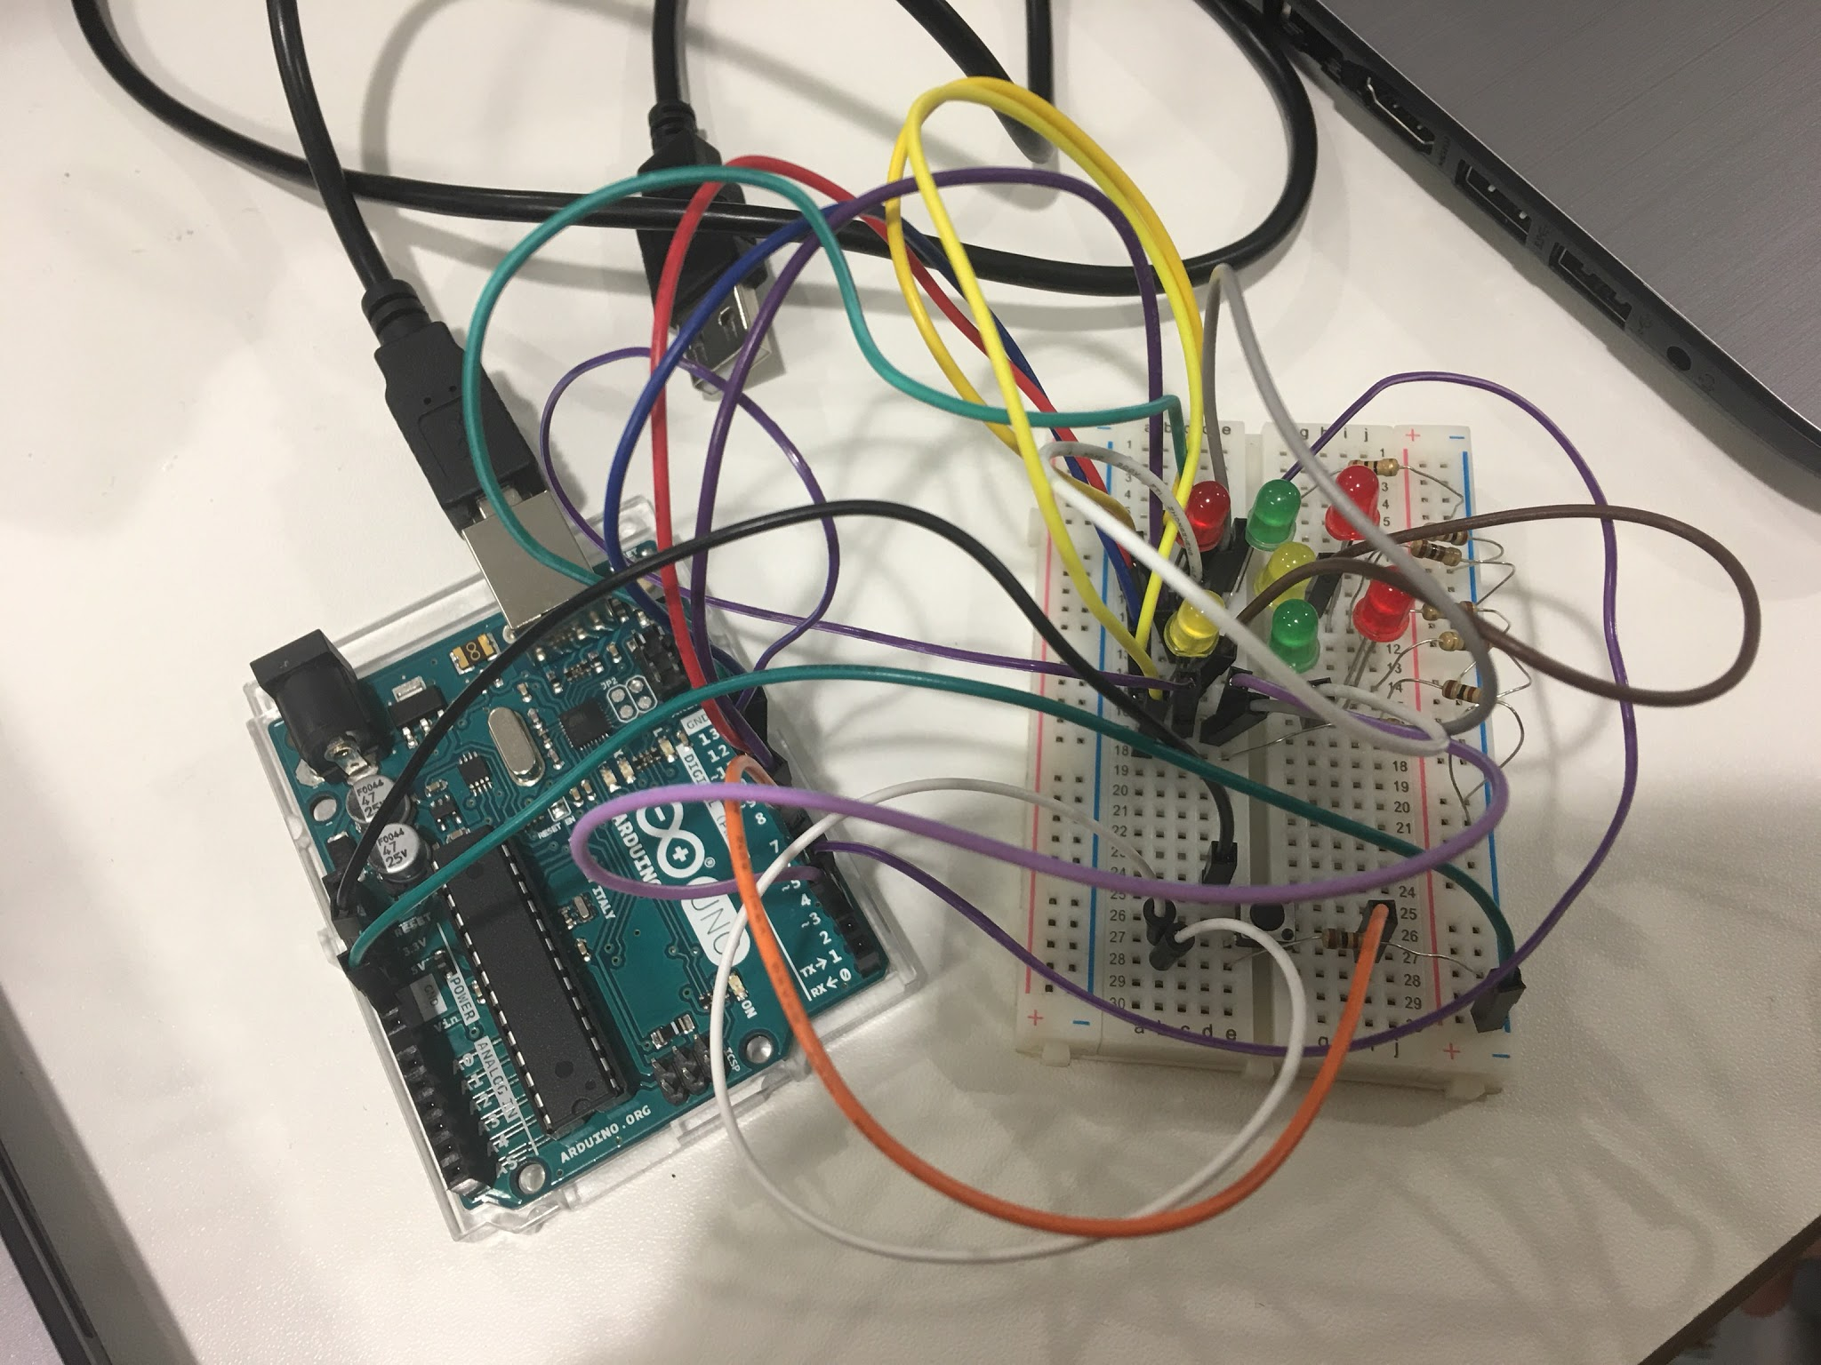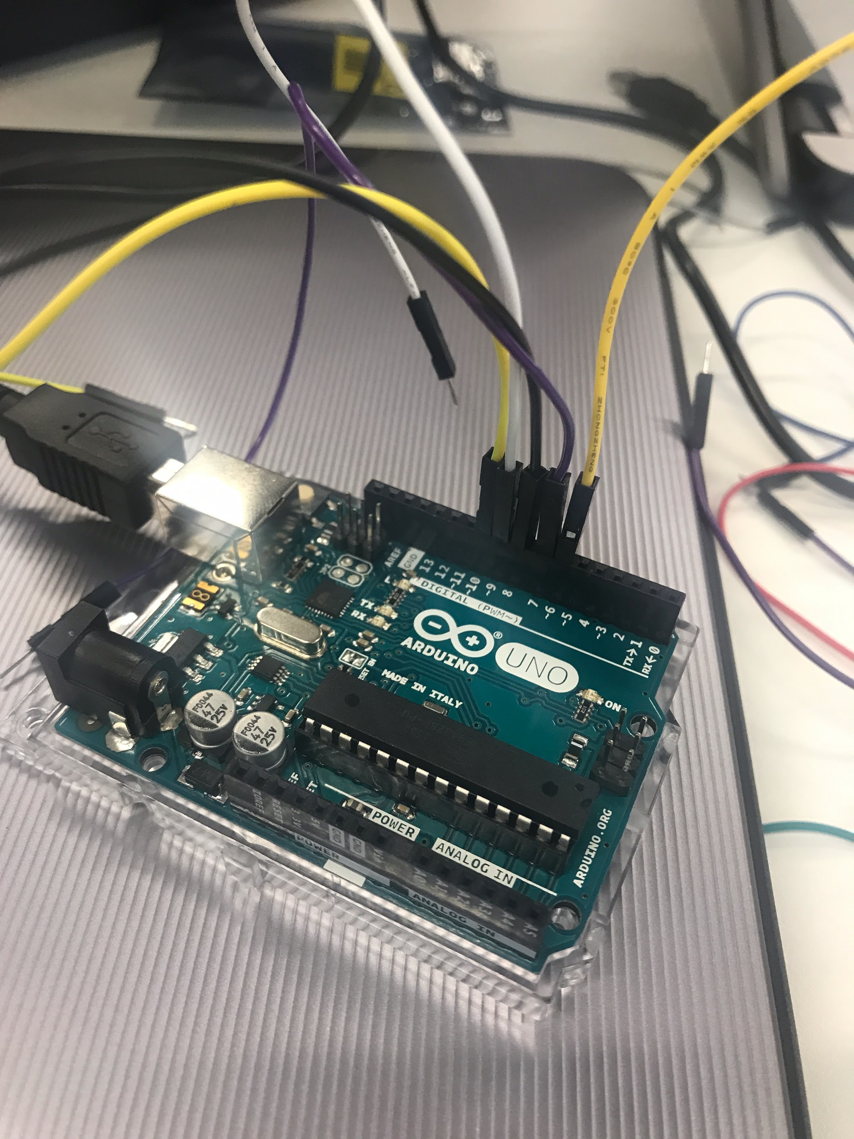

Step 4

Program the code

int pinLeds1 = 10;

int pinLeds2 = 9;

int pinLeds3 = 7;

int pinLeds4 = 8;

int buttonPin = 6;

int pinLed52 = 11;

int test = 2;

int test2 = 3;

int buttonState;

long ran;

int time = 2000;

void setup ()

{

pinMode (pinLeds1, OUTPUT);

pinMode (pinLeds2, OUTPUT);

pinMode (pinLeds3, OUTPUT);

pinMode (pinLeds4, OUTPUT);

pinMode (buttonPin, INPUT);

pinMode (test, OUTPUT);

pinMode (test2, OUTPUT);

randomSeed(analogRead(0));

}

void loop()

{

buttonState = digitalRead(buttonPin);

if (buttonState == HIGH){

ran = random(0, 7);

if (ran == 1){

digitalWrite (pinLeds3, HIGH);

delay (time);

}

if (ran == 2){

digitalWrite (pinLeds4, HIGH);

delay (time);

}

if (ran == 3){

digitalWrite (pinLeds4, HIGH);

digitalWrite (pinLeds3, HIGH);

delay (time);

}

if (ran == 4){

digitalWrite (pinLeds1, HIGH);

digitalWrite (pinLeds4, HIGH);

delay (time);

}

if (ran == 5){

digitalWrite (pinLeds1, HIGH);

digitalWrite (pinLeds3, HIGH);

digitalWrite (pinLeds4, HIGH);

delay (time);

}

if (ran == 6){

pinMode (pinLeds1, OUTPUT);

pinMode (pinLeds2, OUTPUT);

pinMode (pinLeds4, OUTPUT);

pinMode (test, OUTPUT);

pinMode (test2, OUTPUT);

delay (time);

}

}

digitalWrite (pinLeds1, LOW);

digitalWrite (pinLeds2, LOW);

digitalWrite (pinLeds3, LOW);

digitalWrite (pinLeds4, LOW);

digitalWrite (test, LOW);

digitalWrite (test2, LOW);

}

Step 5

Test the dice

